MIDTOWNERS SUNSHINE OF THE WEEK ► July 13th, 2007
Anniversary of Rtn. Lisa and Tenzin Choegyal on July 15th

SPEAKER OF THE WEEK ► None
THEME | Installation Ceremony
We will not have a speaker on the next breakfast meeting since we will be conducting the installation of the new President and Board. The meeting will be attended by our AG and DGE.

UPCOMING SPEAKERS ► PREVIEW
DATE | SPEAKER | THEME
July 20th | Mr. Pramod Poudel  Manager, Kathmandu Gallery | Handicraft and Agro Product Export
July 27th | Ms. Caroline Jacoby  Johns Hopkins Center for Communications Program | Health Education through Radio and TV
Aug 3rd | Ms. Trishna Gurung  Communications and Marketing Manager, WWF Nepal | Global Climate Change

THE MID-TOWN CLUB ► NEWS
LAST WEEK’S TALK
It was a pleasure having our old friend and Mid-Towner back in the Club after almost a year long absence. David gave a progress report on the electric power pedal system project that he has been carrying out in Nepal and Myanmar with the energy award received from the World Bank last year.

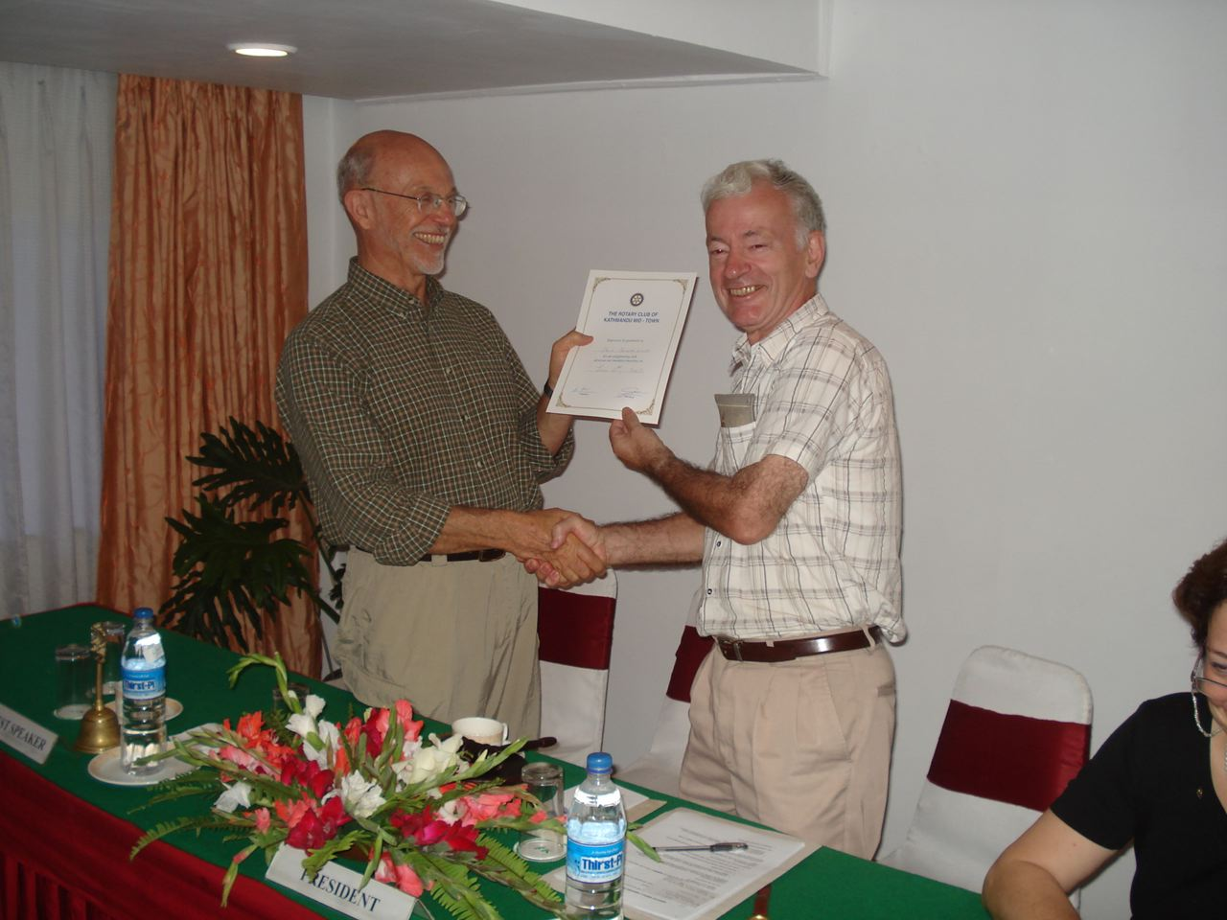
David accepting the certificate of appreciation from President Walter
INSTALLATION PROGRAM
Taking into consideration the tragedy that has befallen our out-going President CK Golchha, we have decided not to hold the annual gala dinner during the installation of the incoming President and Board. We will have a small program during our regular breakfast meeting at Annapurna on July 13th.
TISTUNG STUDENT ZOO VISIT
On July 5th, pupils from our school in Tistung VDC, Makwanpur came on a scheduled free city tour that we organized with the sponsorship of ex-Mid-Towner Larry Meek and his 49er Breakfast Club of Nevada City, California. Headmaster Dharma Lal Shrestha and his colleagues from the Shree Janta School accompanied the pupils to Kathmandu. They were met by President Walter, VP Navyo, ISD Peter and Sgt. At Arms Werner at the Central Zoo.
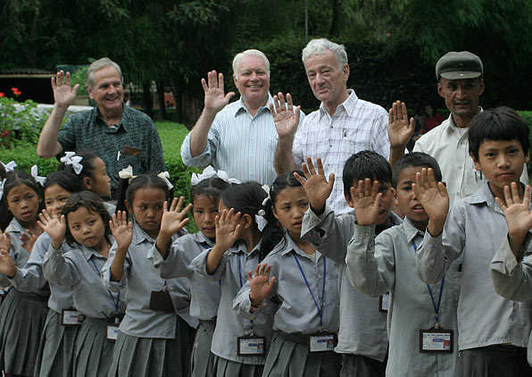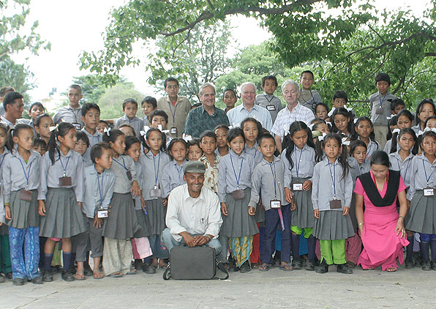
Few pictures from the Tistung students visiting Central Zoo with Mid-Towners

THE ROTARY INTERNATIONAL ► NEWS
In choosing ROTARY SHARES as this year’s theme, RI President Wilfrid Wilkinson had the following to say:
For me, Rotary Shares was the natural choice as the 2007-08 theme. I have always felt that the essence of Rotary is about sharing. Every day, in every club, Rotarians share with others in too many ways to count. We share our time, we share our talents, and we share our resources. We share our kindness, and we share our love.
In Rotary, sharing doesn’t mean giving away the things you don’t need for yourself. In Rotary, sharing means giving of yourself, freely, for the good of others. It means taking the time to see what our communities need and to decide which of those needs we can meet most effectively. It means sharing what we have with those around us, as well as with those we will never have the chance to meet.
All of us came to Rotary to share what we have with others and to share our friendship and fellowship with other Rotarians. We share Rotary with others through bringing in qualified new members, and we share Rotary with the next generation by focusing on youth.
Rotarians have so much to share, and there is so much that the world needs from us. Our vocational classification system ensures that every club contains a full range of business and professional skills. Within every Rotary club, there is a world of talents, skills, and abilities. Each club has the resources to tackle nearly any obstacle – if there is the will and the commitment to do it.
This year, I will ask all of you to say yes to the challenges that being a Rotarian will bring you. Through this year’s emphases of health, literacy, water, and family of Rotary, we have an enormous range of opportunities for service. Those projects, those possibilities, those open doors all await us in the months ahead. All we need to do is say yes.
Yes, I will turn that idea into a project, and I will lead the project to completion.
Yes, I will share my skills, time, and resources with my club and with those who need my help.
Yes, I will share Rotary with others, by bringing a qualified new member into my club.
Did you know?
Paul P. Harris, raised in a rural village in Vermont, was lawyer in Chicago when he envisioned a new kind of club for professionals that would kindle the fellowship and friendly spirit he had known in his youth.On the evening of 23 February 1905, Harris invited three friends to a meeting – Silvester Schiele, a coal dealer; Hiram Shorey, a merchant tailor; Gustavus Loehr, a mining engineer. They gathered in Loehr's business office in Room 711 of the Unity Building. After enlisting a fifth member – printer Harry Ruggles – the group was formally organized as the Rotary Club of Chicago. The original club emblem, a wagon wheel design, was the precursor of the familiar cogwheel emblem now used by Rotarians worldwide.
Editor: Rabi Karmacharya, Club Service Director email: rabikarma@gmailcom

